Recursion
Definition:- when a function calls itself directly or indirectly its known as recursion.
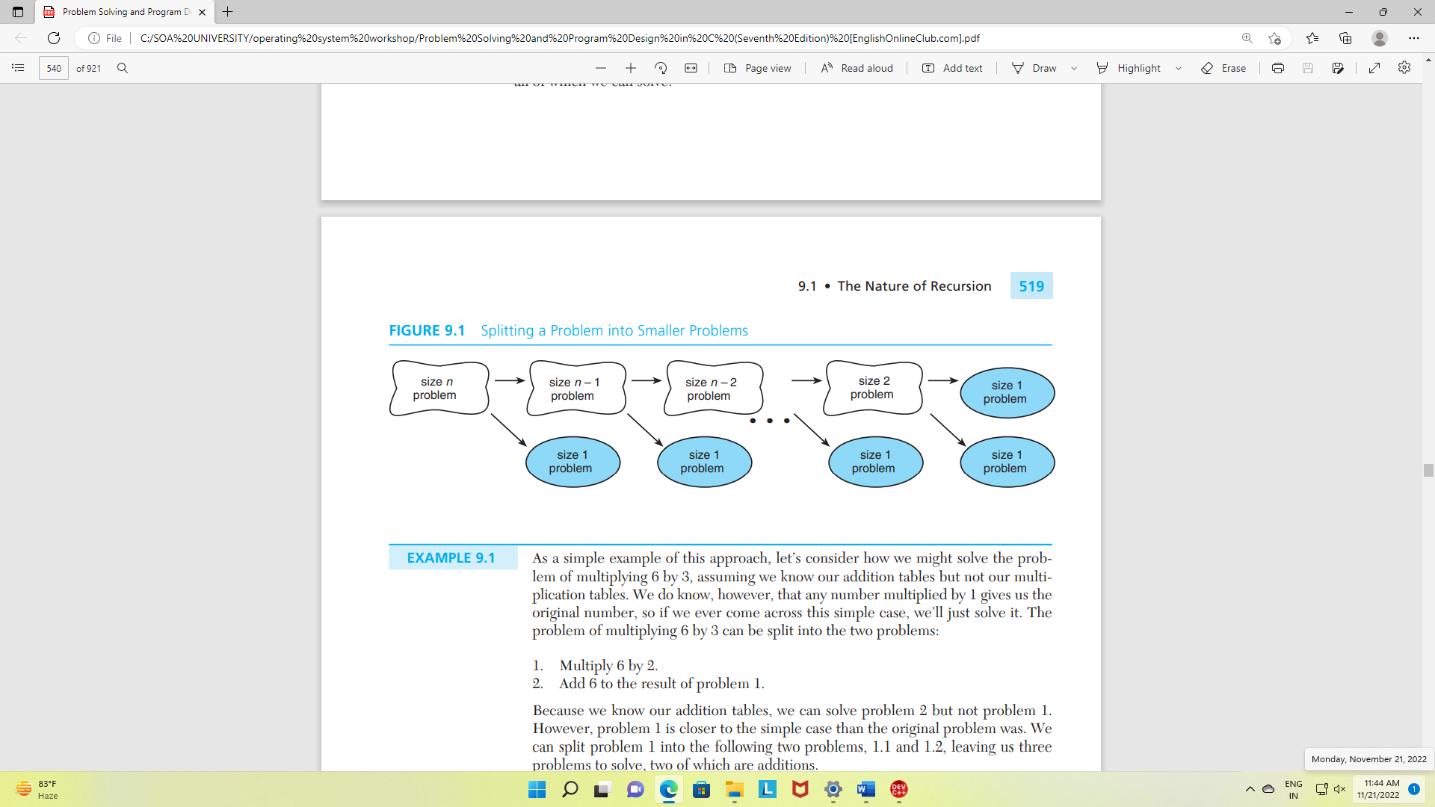
Two most essential elements of the recursion are base case and recursive statement.
- Base case is a case where terminating condition becomes true, terminating condition is a condition that indicates the termination of the recursive function and prevent the recursion from the infinite loop.
- Recursive statement is a statement that holds the call to corresponding function, which will get called recursively every time function gets executed.

Direct recursion:
If the recursive statement is in function itself then it’s known as direct recursion call.
Example:
#include<stdio.h>
int add(int n){
int ans;
if (n==1)
return n;
else{
ans=n+add(n-1);
return ans;
}
}

void main(){
printf("%d", add(5));
}
Indirect recursion:
If the recursive statement is in another function or we can say if the call is made by another function its known as indirect recursion call.

Example:
#include <stdio.h>
void odd();
void even();
int num = 1;
void odd ()
{
if (num <= 10)
{
printf (" %d ", num + 1);
num++;
even();
}
return;
}
void even ()
{
if ( num <= 10)
{
printf (" %d ", num - 1);
num++;
odd();
}
return;
}
int main ()
{
odd();
return 0;
}

Tracing of Recursion

#include<stdio.h>
int multiply(int m, int n)
{
int ans;
if (n == 1)
ans = m; /* simple case */
else
ans = m + multiply(m, n - 1); /* recursive step */
return (ans);
}
void main(){
int c;
c=multiply(6,3);
printf("ANSWER %d", c);
}
NOTE:
In this example, base case will be n=1 and recursive statement will be ans = m + multiply(n-1).
Using splitting problem into smaller problems:
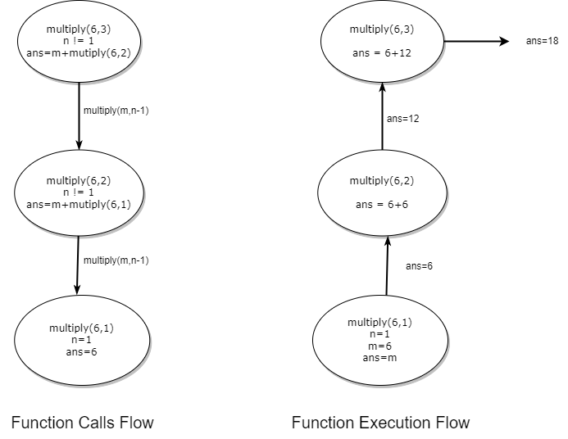
Illustration using activation frame:

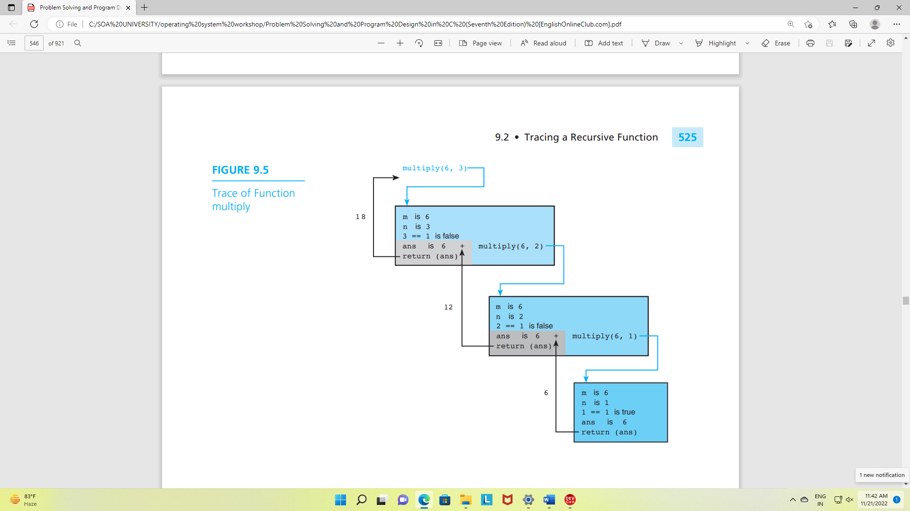

….
To understand recursion more clearly let’s see the illustration of the recursion process through stacks.

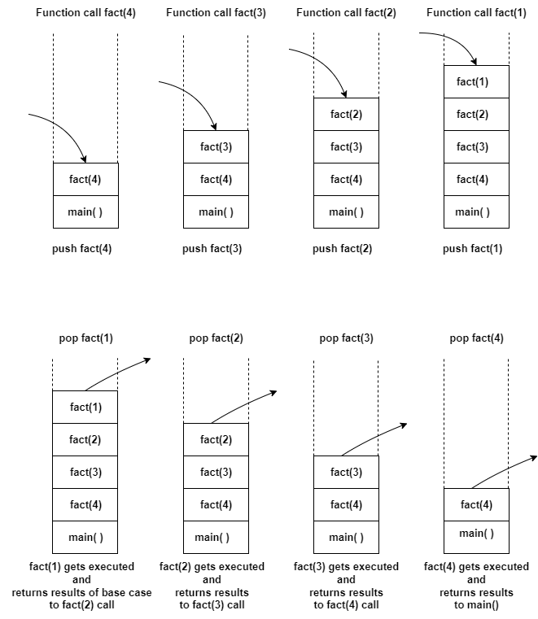

Case Study: Tower of Hanoi
Algorithm:
step1: if n is 1 then
step1.1: move disk 1 from_peg to to_peg
step2: else move n-1 disk from_peg to auxiliary_peg using the to_peg.
step3: move disk n from the from_peg to the to_peg.
step4: move n-1 disks from the auxiliary_peg to the to_peg using the from_peg.
Recursive function
void tower(char from_peg, char to_peg, char aux_peg, int n) {
if (n == 1) {
printf("Move disk 1 from peg %c to peg %c\n", from_peg, to_peg);
} else {
tower(from_peg, aux_peg, to_peg, n - 1);
printf("Move disk %d from peg %c to peg %c\n", n, from_peg, to_peg);
tower(aux_peg, to_peg, from_peg, n - 1);
}
}
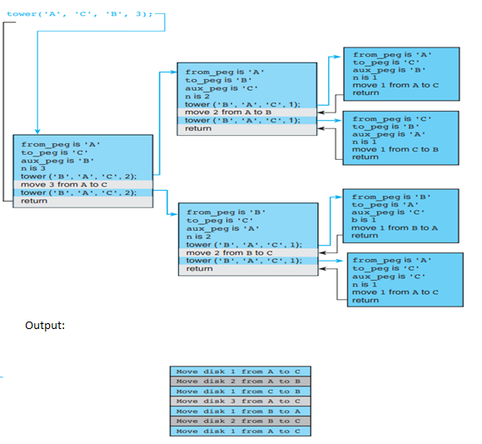

VS \
CRITERIA | RECURSION | ITERATION
Definition | When a function calls itself directly or indirectly. | When some set of instructions are executed repeatedly.
Implementation | Implemented using function calls. | Implemented using loops.
Format | Base case and recursive relation are specified. | Includes initializing control variable, termination condition, and update of the control variable.
Progression | The function state approaches the base case. | The control variable approaches the termination value.
Memory Usage | Uses stack memory to store local variables and parameters. | Does not use memory except initializing control variables.
Infinite Repetition | It will cause stack overflow error and may crash the system if the base case is not defined or is never reached. | It will cause an infinite loop if the control variable does not reach the termination value.
Speed | Slower in execution. | Faster in execution.
Example | Factorial using recursion:  #include<stdio.h>  int factorial(int n)  {  int ans;  if (n == 0)  ans = 1;  else  ans = n * factorial(n - 1);  return (ans);  }  void main(){  int fact;  fact=factorial(3);  printf("FACTORIAL is %d", fact);  } | Factorial using iterative:  #include<stdio.h>  int factorial(int n)  {  int i, product = 1;  for (i = n; i > 1; --i) {  product = product * i;  }  return (product);  }  void main(){  int c;  c=factorial(3);  printf("FACTORIAL is %d", c);  }

Common Programming Errors
If recursive statement has no base case, recursion may result into infinite loop of function calls till the whole memory is used.
A run time error message noting stack overflow or an action violation is an indicator that a recursive function is not terminating.
C permits the use of the return statement anywhere in the function code.
Example
int is_set(const char *set)
{
if (is_empty(set))
return (TRUE);
else if (is_element(set[0], &set[1]))
return (FALSE);
else
return (is_set(&set[1]));
}
The recopying of large arrays or other data structures can quickly consume all available memory. Such copying should be done inside a recursive function only.
On most systems, pressing a control character sequence (e.g., Control S) will temporarily stop output to the screen.

Questions.
- Write a program for counting the occurrences of a character in a string.
- Write a program to find capital letters in a string using recursive function?
- Write a program to find Fibonacci series using recursive function?
- Write a program for recursive selection sort?
- Write a program to find GCD of two integers using recursive function?

